DEPARTMENT OF INFORMATION TECHNOLOGY
JNTU-GURAJADA VIZIANAGARAM
COLLEGE OF ENGINEERING VIZIANAGARAM (A)
VIZIANAGARAM



DJANGO FRAMEWORK LAB
ALUMNI MANAGEMENT SYSTEM
DONE BY

K.HEMANTH KUMAR 23VV1A1224 K.RAGHAVENDRA 23VV1A1221
T.CHAITANYA LAXMI 23VV1A1253
K.LEELA PRASAD 23VV1A1255

UNDER GUIDANCE OF
MRS.MADHUMITA CHANDA

DEPARTMENT OF INFORMATION TECHNOLOGY

Understanding Django and Its Libraries:

What is Django?
Django is a high-level Python web framework that allows developers to build secure, scalable, and maintainable web applications quickly. It follows the MVT architecture (Model-View-Template), which separates business logic, user interface, and database management.

Key Features of Django:
- DRY Principle (Don’t Repeat Yourself): Encourages reusable code and modular design.
- MVT Architecture: Separates core functionalities for better maintainability.
- Built-in Admin Panel: Auto-generated interface to manage database content.
- ORM (Object Relational Mapping): No need to write raw SQL for DB operations.
- Security First: Protection from XSS, CSRF, SQL injection, clickjacking.

Why Use Django?
  - Fast Development: Built-in admin, ORM, and form handling.
  - ecurity: Protection against common vulnerabilities (e.g., XSS, CSRF, SQL injection).
  - Scalable: Used by companies like Instagram, Pinterest, and Disqus.
  - Versatile: Suitable for everything from small apps to enterprise systems.

Django Architecture: MVT Explained
Layer | Role
Model | Handles all database-related work; defines the structure of data.
View | Processes logic and returns a response to the user (often HTML).
Template | Controls how the data is presented (usually HTML + variables).
URLS | Connects user-requested URL’S to Views

Typical Files for URL Handling
File | Purpose
project/urls.py | Global routing for the whole project
app/urls.py | App-specific URL patterns

Why Django is Widely Used
Benefit | Explanation
Speed | Build web apps faster using built-in features.
Security | Automatic protection against common threats.
Scalability | Suitable for both small and enterprise-level projects.
Community Support | A large community provides packages, tutorials, and plugins.
Versatility | Supports content management systems, social networks, APIs, etc.

Common Django Libraries (Extended)
1. django.contrib (Built-in Apps)
Includes modules for authentication, sessions, admin, messages, and static files.
Examples:
- django.contrib.auth: Login/logout and password hashing.
- django.contrib.sessions: Session storage in DB or cache.
- django.contrib.staticfiles: Manages CSS, JS, and image files.

Django REST Framework (DRF)
A robust, flexible toolkit for building Web APIs.
Key Features:
- Serialization of data
- APIView and ViewSets
- Browsable web API
- Authentication (Token, JWT, OAuth)

Crispy Forms
Enhances Django forms with clean layouts using frameworks like Bootstrap or Tailwind.
>> pip install django-crispy-forms
Example:
from crispy_forms.helper import FormHelper

Django Allauth
All-in-one authentication solution.
- Email verification
- Social login (Google, Facebook, GitHub)
- Account management
>>pip install django-allauth

Django Environ
Manages environment variables and keeps settings secure.
pip install django-environ
.env Example:
DEBUG=False
SECRET_KEY=your-secret-key

Typical Django Project Folder Structure (Explained)
myproject/
├── manage.py # CLI for running server, migrations
├── myproject/
│ ├── settings.py # All Django project settings
│ ├── urls.py # Root URL routes
│ ├── wsgi.py # Web server gateway interface
├── appname/
│ ├── models.py # Database models
│ ├── views.py # Business logic
│ ├── urls.py # App-specific URLs
│ ├── templates/ # HTML templates
├── static/ # CSS, JS, images
├── media/ # Uploaded files

How Django Handles Requests
- User visits a URL
- URLconf matches the pattern
- View is called
- View fetches data from Model
- Passes data to a Template
- Template renders response (HTML)

Summary
Topic | Summary
Framework | Django is a full-stack Python framework
Pattern | Follows MVT architecture
Use Case | Build web apps, REST APIs, dashboards
Security | In-built protections for web apps
Popular Sites | Instagram, Pinterest, Mozilla, Disqus

PYTHON LIBRARIES
Python Collections - Container Datatypes:
- Purpose: Provides specialized container datatypes that support efficient handling of data.
- Key Types:
- List: Ordered, mutable, allows duplicates.
- Tuple: Ordered, immutable, allows duplicates.
- Set: Unordered, no duplicates, fast membership testing.
- Dictionary: Unordered, key-value pairs, fast lookups.
Common Use: Data manipulation, storing and accessing collections of data
in web apps (like user data or API responses).

- Tkinter - GUI Applications:
  - Purpose: Python’s standard library for creating graphical user interfaces (GUIs).
  - Key Features:
- Widgets: Buttons, labels, text boxes, etc.
- Event handling: Respond to user interactions like clicks or key presses.
- Simple layout management.
Common Use: Build desktop applications or tools for local interaction.
Code:
import tkinter as tk # Import tkinter for GUI
from tkinter import messagebox # Import messagebox for popup dialogs

def greet(): # Function to run when button is clicked
name = name_entry.get() # Get text entered by user
messagebox.showinfo("Greeting", # Show greeting in a popup
f"Hello, {name}! Welcome to Tkinter GUI.")

window = tk.Tk() # Create the main application window
window.title("Greeting App") # Set the window title
window.geometry("300x200") # Set size of the window (width x height)

tk.Label(window, text="Enter your name:").pack(pady=10) # Add a label with some padding

name_entry = tk.Entry(window, width=25) # Create a text entry box
name_entry.pack(pady=5) # Add spacing below the entry

greet_button = tk.Button(window, text="Greet Me", command=greet) # Button triggers greet()
greet_button.pack(pady=20) # Add padding below the button

window.mainloop() # Start the Tkinter event loop
window = tk.Tk() # Create main application window
window.title("Greeting App") # Set window title
window.geometry("300x200") # Set window size (width x height)

label = tk.Label(window, text="Enter your name:") # Create a label
label.pack(pady=10) # Add some vertical spacing and pack it

name_entry = tk.Entry(window, width=25) # Create a text entry field
name_entry.pack(pady=5) # Pack it with vertical spacing

greet_button = tk.Button(window, text="Greet Me", command=greet)
# Create a button
greet_button.pack(pady=20) # Pack it with vertical
spacing

window.mainloop() # Start the GUI event loop
Output:
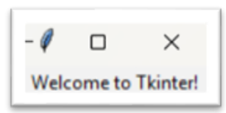

- Requests - HTTP Requests:
  - Purpose: Simplifies HTTP requests to interact with web APIs.
  - Key Features:
- Send GET, POST, PUT, DELETE requests easily.
- Handle request parameters, headers, and cookies.
- Simple error handling and response handling.
Common Use: Interact with REST APIs, download content from
the web.

Code:
import requests # Import the requests library to send HTTP requests

# Base URL for API (example)
url = "https://jsonplaceholder.typicode.com/posts" # Example API URL

# Example of GET request
def get_request(): # Define the function to handle GET request
try:
response = requests.get(url) # Sending GET request to the API
response.raise_for_status() # Raise an exception for HTTP errors
print("GET Response:")
print(response.json()) # Parse and print JSON response
except requests.exceptions.HTTPError as err: # Catch HTTP error exceptions
print(f"HTTP error occurred: {err}") # Handle HTTP errors
except Exception as err: # Catch any other general errors
print(f"An error occurred: {err}") # Handle other errors

# Example of POST request
def post_request(): # Define the function to handle POST request
try:
data = {"title": "foo", "body": "bar", "userId": 1} # Data to send with POST
response = requests.post(url, json=data) # Sending POST request with JSON data
response.raise_for_status() # Check for HTTP errors
print("\nPOST Response:")
print(response.json()) # Print the response JSON
except requests.exceptions.HTTPError as err: # Catch HTTP error exceptions
print(f"HTTP error occurred: {err}") # Handle HTTP errors
except Exception as err: # Catch any other general errors
print(f"An error occurred: {err}") # Handle other errors

# Example of PUT request
def put_request(post_id): # Define the function to handle PUT request with post ID
try:
data = {"title": "foo updated", "body": "bar updated", "userId": 1}

# Data to update
response = requests.put(f"{url}/{post_id}", json=data) # Sending PUT request to update data
response.raise_for_status() # Check for HTTP errors
print("\nPUT Response:")
print(response.json()) # Print the response JSON
except requests.exceptions.HTTPError as err: # Catch HTTP error exceptions
print(f"HTTP error occurred: {err}") # Handle HTTP errors
except Exception as err: # Catch any other general errors
print(f"An error occurred: {err}") # Handle other errors

# Example of DELETE request
def delete_request(post_id): # Define the function to handle DELETE request with post ID
try:
response = requests.delete(f"{url}/{post_id}") # Sending DELETE request to delete data
response.raise_for_status() # Check for HTTP errors
print("\nDELETE Response:")
print("Post deleted successfully!" if response.status_code == 200 else "Failed to delete post") # Check if deletion was successful
except requests.exceptions.HTTPError as err: # Catch HTTP error exceptions
print(f"HTTP error occurred: {err}") # Handle HTTP errors
except Exception as err: # Catch any other general errors
print(f"An error occurred: {err}") # Handle other errors

# Example of GET request with parameters
def get_with_parameters(): # Define the function to handle GET request with parameters
params = {"userId": 1} # Example parameters
try:
response = requests.get(url, params=params) # Sending GET request with query parameters
response.raise_for_status() # Check for HTTP errors
print("\nGET with Parameters Response:")
print(response.json()) # Print the response JSON
except requests.exceptions.HTTPError as err: # Catch HTTP error exceptions
print(f"HTTP error occurred: {err}") # Handle HTTP errors
except Exception as err: # Catch any other general errors
print(f"An error occurred: {err}") # Handle other errors

# Example of GET request with custom headers
def get_with_headers(): # Define the function to handle GET request with custom headers
headers = {"Authorization": "Bearer your_token_here"} # Custom headers (e.g., for authorization)
try:
response = requests.get(url, headers=headers)# Sending GET request with custom headers
response.raise_for_status() # Check for HTTP errors
print("\nGET with Headers Response:")
print(response.json()) # Print the response JSON
except requests.exceptions.HTTPError as err: # Catch HTTP error exceptions
print(f"HTTP error occurred: {err}") # Handle HTTP errors
except Exception as err: # Catch any other general errors
print(f"An error occurred: {err}") # Handle other errors

# Example of sending cookies with a request
def get_with_cookies(): # Define the function to handle GET request with cookies
cookies = {"session_id": "your_session_id_here"} # Example cookies
try:
response = requests.get(url, cookies=cookies) # Sending GET request with cookies
response.raise_for_status() # Check for HTTP errors
print("\nGET with Cookies Response:")
print(response.json()) # Print the response JSON
except requests.exceptions.HTTPError as err: # Catch HTTP error exceptions
print(f"HTTP error occurred: {err}") # Handle HTTP errors
except Exception as err: # Catch any other general errors
print(f"An error occurred: {err}") # Handle other errors

# Example execution of requests
if __name__ == "__main__": # Main execution block
get_request() # Call the GET request function
post_request() # Call the POST request function
put_request(1) # Update post with ID 1 using PUT request
delete_request(1) # Delete post with ID 1 using DELETE request
get_with_parameters() # Send GET request with parameters
get_with_headers() # Send GET request with custom headers
get_with_cookies() # Send GET request with cookies

Ouput:
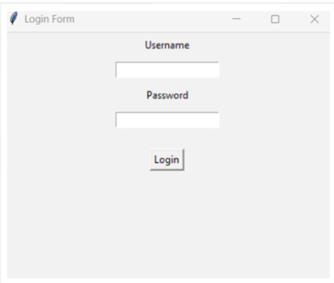

4. Scrapy:
- Purpose: An open – source web crawling framework for large – scale web scraping.
- Key Features:
- Fast, extensible, and asynchronous web scraping.
- Supports handling requests, data extraction, and storing results.
- Built-in handling for logging, retries, and sessions.
Common Use: Web crawling and scraping projects that require high performance.

5. BeautifulSoup – Web Scraping:
- Purpose: Parses HTML and XML documents to extract data.
- Key Features:
- Easy navigation and searching within HTML.
- Support different parses like html.parser , lxml, and html5lib.
Common use: Extra data from website for analysis , e.g., for building data – driven applications.

Code:

import requests # Import requests to make HTTP requests
from bs4 import BeautifulSoup # Import BeautifulSoup for HTML parsing

url = 'https://example.com' # The target URL to scrape

response = requests.get(url) # Send GET request to the URL

soup = BeautifulSoup(response.content, 'html.parser') # Parse HTML content using 'html.parser'

links = soup.find_all('a') # Find all <a> tags (hyperlinks)

print("All Links on the Page:")
for link in links:
href = link.get('href') # Extract 'href' attribute from each <a> tag
print(">>", href) # Print the hyperlink

title = soup.find('h1').get_text() # Extract text inside the first <h1> tag
print("\nPage Title from <h1> tag:", title) # Print the <h1> title

page_title = soup.title.string # Extract the title from the <title> tag in <head>
print("Title of the page from <title> tag:", page_title) # Print the <title> tag content

Output:
Ps C:\Users\raghava\django_project\python>
>> http://www.iana.org/domains/example
>>Page Title: Domain
>>Title of the page:Domain

6.Zappa:
- Purpose: Deploy Python web applications to AWS Lambda and API Gateway.
- Key Features:
- Supports frameworks like Flask and Django for serverless deployments.
- Manages serverless architecture and deployment configurations.
Common Use: Build scalable, serverless web apps without maintaining servers.

7. Dash:
- Purpose: Web application framework for building interactive data visualization applications.
- Key Features:
  - Built on top of Flask, React, and Plotly.
  - Integrates seamlessly with data science libraries (e.g., Pandas, Plotly).
Common Use: Building dashboards and data-driven web applications.

8. TurboGears:
- Purpose: Full-stack web framework built on top of WSGI.
- Key Features:
  - Modular: Mix and match components like SQL Alchemy, Genshi, and others.
  - Focus on rapid development and scalability.
Common Use: Develop scalable, enterprise-level web applications.

9. CherryPy:
- Purpose: Minimalistic web framework for building web applications.
- Key Features:
  - Provides a simple and fast HTTP server.
  - Handles routing, cookies, sessions, and file uploads.
Common Use: Building web applications with a lightweight framework.
Code:
import cherrypy # Import CherryPy framework

class HelloWorld: # Define main app class
@cherrypy.expose # Make method a web-accessible endpoint
def index(self): # Route: http://127.0.0.1:8080/
return "Hello, this is a CherryPy web app!" # Plain response

@cherrypy.expose # Another web-accessible endpoint
def greet(self, name="Guest"): # Route: http://127.0.0.1:8080/greet?name=Haritha
return f"Hello, {name}! Welcome to CherryPy." # Personalized greeting

if __name__ == '__main__': # Run only if executed directly
cherrypy.quickstart(HelloWorld()) # Start CherryPy server

Output:
[12/Apr/2025:14:05:20] ENGINE Listening for SIGTERM.
[12/Apr/2025:14:05:20] ENGINE Bus STARTING
[12/Apr/2025:14:05:20] ENGINE Started monitor thread 'Autoreloader'.
[12/Apr/2025:14:05:20] ENGINE Serving on http://127.0.0.1:8080
[12/Apr/2025:14:05:20] ENGINE Bus STARTED
After run the server :-
Hello,World! This is a cherrypie web page.

10.Flask:
- Purpose: Lightweight micro – framework for building web applications.
- Key Features:
- Simple to learn and use , but highly extensible.
- Support extensions for database integration , form handling ,Authentication.
Common Use: Small to medium web applications , APIs , or microservices.
Code:
from flask import Flask, request # Import Flask and request object

app = Flask(__name__) # Create Flask app instance

@app.route('/') # Route: http://127.0.0.1:5000/
def home(): # Home page view function
return "Hello, this is a Flask web app!" # Response message

@app.route('/greet') # Route: http://127.0.0.1:5000/greet?name=Haritha
def greet(): # Greet page view function
name = request.args.get('name', 'Guest') # Get name from URL, default = Guest
return f"Hello, {name}! Welcome to Flask." # Personalized response

if __name__ == '__main__': # Run app only if executed directly
app.run(debug=True) # Start Flask development server

Output:
PS C:\Users\Haritha.vana\flask_project> python app.py
* Serving Flask app 'app'
* Debug mode: on
WARNING: This is a development server. Do not use it in a production deployment.
* Running on http://127.0.0.1:5000
Press CTRL+C to quit
* Restarting with stat
* Debugger is active!
* Debugger PIN: 123-456-789
After Run the server:
Hello,World!

11. Web2Py:
- Purpose: Full-stack framework for rapid web application development.
- Key Features:
  - Includes a web-based IDE for development.
  - Built-in ticketing system and database integration.
Common Use: Enterprise web applications with minimal setup.

12. Bottle:
- Purpose: Simple and lightweight WSGI micro-framework.
- Key Features:
  - Single-file framework, minimalistic, and fast.
  - No dependencies, supports routing, templates, and form handling.
Common Use: Small web applications, APIs, and prototypes.

Code:
from bottle import Bottle, run, request # Import Bottle framework and necessary modules

app = Bottle() # Create an instance of the Bottle application

@app.route('/') # Route: http://127.0.0.1:8080/
def home(): # Home page function
return "Hello, this is a Bottle web app!" # Response message for home route

@app.route('/greet') # Route: http://127.0.0.1:8080/greet?name=Haritha
def greet(): # Greet page function
name = request.query.get('name', 'Guest') # Get name from query parameter (default is 'Guest')
return f"Hello, {name}! Welcome to Bottle." # Personalized greeting response

if __name__ == '__main__': # Run the app only if executed directly
run(app, host='127.0.0.1', port=8080) # Start the Bottle development server
Output:
PS C:\Users\raghava\bottle_project> python app.py
Bottle: Starting bottle server on http://127.0.0.1:8080/
Listening on http://127.0.0.1:8080/
Press Ctrl+C to quit.
After run the server:
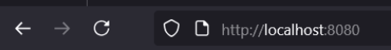

Hello,World! This is a Bottel web page.

13. Falcon:
- Purpose: High-performance framework for building APIs.
- Key Features:
  - Focuses on speed and minimalism.
  - Supports RESTful API development and is optimized for large-scale deployments.
Common Use: Building fast, high-performance APIs.

14. CubicWeb:
- Purpose: Web application framework based on an entity-relation model.
- Key Features:
  - Uses a highly modular architecture for development.
  - Focus on building web apps with rich data models.
Common Use: Semantic web applications or data-driven web apps.

15. Quixote:
- Purpose: A web framework designed for simplicity and scalability.
- Key Features:
  - Full support for Python’s object-oriented programming.
  - Easily extensible, with minimalistic core.
Common Use: Scalable and customizable web applications.

16. Pyramid:
- Purpose: Full-stack web framework that can scale from simple to complex applications.
- Key Features:
  - Highly flexible with support for routing, templating, authentication, and authorization.
  - Allows for small and large applications, with fine-grained control.
Common Use: Building large, enterprise-grade web applications and REST APIs.

SUMMARY:
- Flask, Django, Pyramid: Popular web frameworks, each offering flexibility and scalability.
- Scrapy, BeautifulSoup4: Specialized for web scraping and data extraction.
- Requests, Zappa, Dash: Tools for making HTTP requests, serverless apps, and interactive data visualizations.
- Tkinter, Bottle, CherryPy: Libraries for building lightweight desktop and web applications.

INTRODUCTION TO DJANGO FRAMEWORK

What is Django?
Definition
Django is a high-level, open-source web framework written in Python that promotes rapid development and clean, pragmatic design. It follows the "batteries-included" philosophy, meaning it comes with a wide range of built-in features for building web applications efficiently.

Brief History
Django was created in 2003 by Adrian Holovaty and Simon Willison while working at the Lawrence Journal-World newspaper in Kansas, USA. It was released publicly under a BSD license in July 2005. Since then, Django has grown to become one of the most popular Python web frameworks.

Django's Purpose
The main goal of Django is to simplify the process of developing complex, database-driven websites. It emphasizes reusability, rapid development, and the principle of DRY (Don't Repeat Yourself). Django includes tools for user authentication, content administration, site maps, RSS feeds, and many other tasks that are common in web development.

Comparison with Other Frameworks
Django stands out among other frameworks due to its robust features and ease of use. Here's a quick comparison:

Framework | Language | Strengths
Django | Python | Rapid development, built-in tools
Laravel | PHP | Elegant syntax, MVC pattern
Ruby on Rails | Ruby | Convention over configuration
Flask | Python | Lightweight and flexible

Django is ideal for developers who want a complete toolkit out of the box, while still maintaining flexibility and scalability.

Key Features of Django
Batteries-Included Philosophy
Django comes with a rich set of features including authentication, URL routing, template engine, ORM, and more. This allows developers to focus more on application logic rather than building these components from scratch.

Security
Django has strong security features and helps developers avoid common security mistakes like SQL injection, cross-site scripting, cross-site request forgery, and clickjacking.
Scalability
Django is designed to handle high-traffic applications. It’s used by large-scale companies like Instagram, Pinterest, and Disqus.
Django Admin Panel
One of Django’s most powerful features is its auto-generated admin interface. It allows developers and admins to manage content and data with minimal setup.
Object-Relational Mapping (ORM)
Django’s ORM allows you to define your data models entirely in Python. It provides a high-level abstraction upon a relational database.
Middleware Support
Django uses middleware to process requests and responses globally. It’s useful for managing sessions, user authentication, and more.

Django Architecture and Components
MTV Architecture
Django follows the Model-Template-View (MTV) architecture:
- Model: Defines the data structure. It is a Python class that maps to a database table.
- Template: Controls how data is displayed. It is an HTML file with Django template language.
- View: Contains the logic that processes user requests and returns responses.
Although it is similar to the MVC (Model-View-Controller) pattern, Django’s terminology differs slightly.

URL Dispatcher
Django’s URL dispatcher maps URLs to views using regular expressions or path converters. This allows clean and readable URL structures

Templates
Templates define the layout and structure of web pages using HTML and Django’s template language. They help separate the design from the business logic.

Forms
Django provides a powerful form handling library that supports form validation, rendering, and error messages.

Admin Interface
The admin interface is built automatically from models, making it easy to manage database records.

Development Server
Django includes a lightweight web server for testing and development, which helps developers test their application quickly.

Working with Django – Development Process
Setting Up a Django Project
To start a Django project:

>>pip install django
>>django-admin startproject myproject
>>cd myproject
>>python manage.py runserver

Creating Apps
Django projects are composed of apps. To create an app:
>>python manage.py startapp myapp

Defining Models
Models are defined in models.py:
from django.db import models
class Student(models.Model):
name = models.CharField(max_length=100)
age = models.IntegerField()

Running Migrations
Migrations apply changes to the database schema:
>>python manage.py makemigrations
>>python manage.py migrate

Creating Views
Views are defined in views.py:
from django.http import HttpResponse
def home(request):
return HttpResponse("Welcome to Django!")

Mapping URLs
URLs are mapped in urls.py:
from django.urls import path
from . import views

urlpatterns = [
path('', views.home, name='home'),
]

Benefits and Use Cases
Advantages of Django
- Rapid Development: Built-in tools help developers create applications quickly.
- Secure by Default: Protects against many common security threats.
- Scalable and Reliable: Suitable for both small and large applications.
- DRY Principle: Avoids repetition in code.
- Robust Ecosystem: Includes third-party packages for additional functionality.

Real-World Applications
Django powers many well-known websites and services:
- Instagram: Handles millions of users and images daily.
- Pinterest: Visual discovery platform with heavy traffic.
- Disqus: Blog comment hosting service.
- Mozilla: Part of Mozilla's web services uses Django.

When to Use Django
Django is suitable for:
- Content management systems (CMS)
- E-commerce websites
- Social media platforms
- API backends using Django REST Framework
- Scientific data platforms

In conclusion, Django is a versatile, robust, and secure web development framework ideal for both beginners and experienced developers looking to build scalable and maintainable applications efficiently.

DJANGO INSTALLATION

Step-1: Checking the installation & version of Python & PIP
>>python --version
>>pip –version

Step-2: Installation of Virtual Environment
>>pip install virtualenvwrapper-win

Step-3: Creation of Virtual Environment
>>mkvirtualenv (name)

Step-4: Installation of Django in Virtual Environment
>>pip install Django

Step-5: Create a folder to store all the projects
>>mkdir proj_folder_name

Step-6: Start new project
>>django-admin startproject project_name
>>django-admin startapp app_name

Step-7: Run the server
>>python manage.py runserver

Step-8: Open the browser and check the homepage of Django.

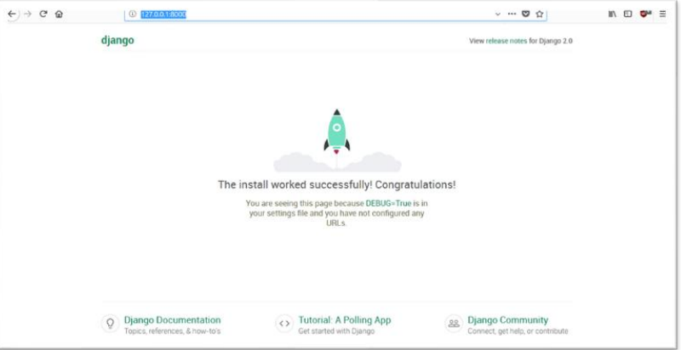
Output:
PROJECT CREATION
Command used : django-admin startproject alumni_portal1
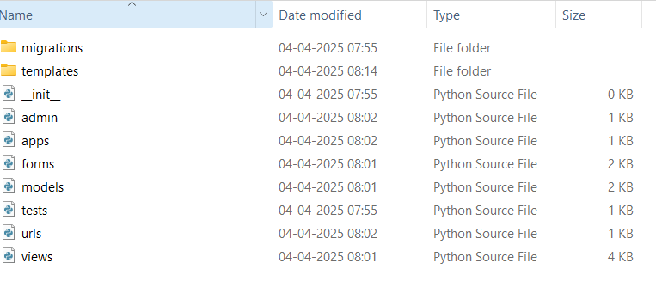

APP CREATION
Command used : django-admin startproject alumni
APP’s, URL’s, VIEW’s CREATION

1.App’s.py
from django.apps import AppConfig
class GroupsConfig(AppConfig):
name = 'groups' # Name of the app
verbose_name = 'Alumni management system' # Optional, used in the admin panel

2.Views.py
from django.shortcuts import render, redirect
from django.http import HttpResponse
from .models import Alumni_portal1 # Assuming AlumniGfroup model is defined in models.py
from .forms import Alumni # Assuming AlumniForm is defined in forms.py

# View to display all Alumni groups
def group_list(request):
groups = StudyGroup.objects.all() # Fetch all study groups
return render(request, 'groups/group_list.html', {'groups': groups}) # Render the group_list.html template

# View to display a specific study group
def group_detail(request, pk):
group = StudyGroup.objects.get(pk=pk) # Fetch specific group by its primary key
return render(request, 'groups/group_detail.html', {'group': group}) # Render the group_detail.html template

# View to create a new study group
def create_group(request):
if request.method == 'POST':
form = StudyGroupForm(request.POST) # Bind form data to the StudyGroupForm
if form.is_valid():
form.save() # Save the new study group to the database
return redirect('group_list') # Redirect to the group list after successful creation
else:
form = StudyGroupForm() # Instantiate an empty form

return render(request, 'groups/create_group.html', {'form': form}) # Render the form to create a new group

3.Urls.py

from django.contrib import admin
from django.urls import path, include
from django.conf import settings
from django.conf.urls.static import static

urlpatterns = [
path('admin/', admin.site.urls),
path('', include('users.urls')),
path('groups/', include('groups.urls')),
path('materials/', include('materials.urls')),
path('videos/', include('videos.urls')),
]

if settings.DEBUG:
urlpatterns += static(settings.MEDIA_URL, document_root=settings.MEDIA_ROOT)

CONNECTING VIEWS AND URLS
Set Up URLs:
Project-level URL Configuration:
from django.contrib import admin
from django.urls import path, include
urlpatterns = [
path('admin/', admin.site.urls),
path('', include('myapp1.urls')), # Include app URLs
]

App-level URL Configuration:
from django.urls import path
from .views import home
urlpatterns = [
path('', home, name='home'),
]

Create a Sample View:
from django.http import HttpResponse
def home(request):
return HttpResponse("<h1>Welcome to My Django App!</h1>")

Run Migrations:
python manage.py migrate

Run the Server and Test:
python manage.py runserver

Exploring Views
3. Views.py
In Django, views.py is the file where you define functions or classes that handle requests and return responses. Views act as the logic layer of a Django web application, controlling how data is processed and which HTML templates are displayed.
Code:
from django.shortcuts import render, redirect, get_object_or_404
from django.contrib.auth import login, authenticate, logout
from django.contrib.auth.decorators import login_required
from .forms import UserRegisterForm, AlumniForm,EventForm
from .models import Alumni, Event, EventRegistration,AnnouncementReadStatus,Announcement
from django.contrib.auth.models import User
from django.contrib import messages

def register_alumni(request):
if request.method == 'POST':
user_form = UserRegisterForm(request.POST)
alumni_form = AlumniForm(request.POST, request.FILES)
if user_form.is_valid() and alumni_form.is_valid():
user = user_form.save(commit=False)
user.set_password(user.password)
user.save()
alumni = alumni_form.save(commit=False)
alumni.user = user
alumni.save()
login(request, user)
return redirect('profile')
else:
user_form = UserRegisterForm()
alumni_form = AlumniForm()
return render(request, 'alumni/register.html', {'user_form': user_form, 'alumni_form': alumni_form})

def login_view(request):
if request.method == 'POST':
username = request.POST.get('username')
password = request.POST.get('password')
user = authenticate(request, username=username, password=password)
if user:
login(request, user)
return redirect('profile')
return render(request, 'alumni/login.html')

@login_required

def logout_view(request):
logout(request)
return redirect('login')

@login_required
def profile(request):
alumni = get_object_or_404(Alumni, user=request.user)
if request.method == 'POST':
form = AlumniForm(request.POST, request.FILES, instance=alumni)
if form.is_valid():
form.save()
else:
form = AlumniForm(instance=alumni)
return render(request, 'alumni/profile.html', {'form': form})

def event_list(request):
events = Event.objects.all()
return render(request, 'alumni/event_list.html', {'events': events})

@login_required
def event_register(request, id):
event = get_object_or_404(Event, id=id)
alumni = get_object_or_404(Alumni, user=request.user)
EventRegistration.objects.get_or_create(event=event, alumni=alumni)
return redirect('event_list')

from django.shortcuts import render, redirect
from .forms import UserRegisterForm, AlumniForm
from django.contrib.auth import login
from django.contrib.auth.models import User

def signup_view(request):
if request.method == 'POST':
user_form = UserRegisterForm(request.POST)
alumni_form = AlumniForm(request.POST, request.FILES)

if user_form.is_valid() and alumni_form.is_valid():
user = user_form.save(commit=False)
user.set_password(user.password)
user.save()

alumni = alumni_form.save(commit=False)
alumni.user = user
alumni.save()

login(request, user) # Log the user in after signup
return redirect('profile') # Redirect to profile page
else:
user_form = UserRegisterForm()
alumni_form = AlumniForm()

return render(request, 'alumni/signup.html', {
'user_form': user_form,
'alumni_form': alumni_form
})

from django.shortcuts import render

def home(request):
return render(request, 'alumni/home.html')
@login_required
def alumni_list(request):
query = request.GET.get('q')
if query:
alumni = Alumni.objects.filter(user_first_nameicontains=query) | Alumni.objects.filter(course_icontains=query)
else:
alumni = Alumni.objects.all()
return render(request, 'alumni/alumni_list.html', {'alumni_list': alumni})
def announcements(request):
from .models import Announcement
announcements = Announcement.objects.order_by('-date_posted')
return render(request, 'alumni/announcements.html', {'announcements': announcements})
from django.contrib.admin.views.decorators import staff_member_required

@staff_member_required
def admin_dashboard(request):
total_alumni = Alumni.objects.count()
total_events = Event.objects.count()
recent_regs = EventRegistration.objects.select_related('alumni', 'event').order_by('-id')[:5]
return render(request, 'alumni/admin_dashboard.html', {
'total_alumni': total_alumni,
'total_events': total_events,
'recent_regs': recent_regs,
})

@staff_member_required
def create_announcement(request):
from .forms import AnnouncementForm
if request.method == 'POST':
form = AnnouncementForm(request.POST)
if form.is_valid():
form.save()
return redirect('announcements')
else:
form = AnnouncementForm()
return render(request, 'alumni/create_announcement.html', {'form': form})
from .models import Announcement, AnnouncementReadStatus, Alumni
from django.contrib.auth.decorators import login_required
from django.shortcuts import render, get_object_or_404

@login_required
def announcements(request):
alumni = get_object_or_404(Alumni, user=request.user)
announcements = Announcement.objects.all().order_by('-date_posted')

for ann in announcements:
# Mark unread announcements as read when viewed
read_status, created = AnnouncementReadStatus.objects.get_or_create(alumni=alumni, announcement=ann)
if not read_status.read:
read_status.read = True
read_status.save()

return render(request, 'alumni/announcements.html', {'announcements': announcements})

def unread_announcements_count(request):
if request.user.is_authenticated:
alumni = Alumni.objects.filter(user=request.user).first()
if alumni:
count = AnnouncementReadStatus.objects.filter(alumni=alumni, read=False).count()
return {'unread_announcement_count': count}
return {}

def add_event(request):
if request.method == 'POST':
form = EventForm(request.POST)
if form.is_valid():
form.save()
messages.success(request, 'Event created successfully!')
return redirect('admin_dashboard')
else:
form = EventForm()
return render(request, 'alumni/add_event.html', {'form': form})

URLS FOR APPS
Creating urls.py in a Django App:
Each Django app should have its own urls.py file to define app-specific routes.
Steps to Create urls.py in a Django App
- Inside your Django app folder (myapp1), create a file named urls.py.
- Define URL patterns to map URLs to views.
Code:
from django.urls import path
from django.urls import path
from . import views

urlpatterns = [
path('', views.home, name='home'),
path('signup/', views.signup_view, name='signup'),
path('register/', views.register_alumni, name='register'),
path('login/', views.login_view, name='login'),
path('logout/', views.logout_view, name='logout'),
path('profile/', views.profile, name='profile'),
path('events/', views.event_list, name='event_list'),
path('events/<int:id>/register/', views.event_register, name='event_register'),
path('alumni/', views.alumni_list, name='alumni_list'),
path('announcements/', views.announcements, name='announcements'),
path('admin-board/', views.admin_dashboard, name='admin_dashboard'),
path('dashboard/events/add/', views.add_event, name='add_event'),
# 🔄 Updated to avoid conflict
path('dashboard/announcement/new/', views.create_announcement, name='create_announcement'),
]

Connecting App urls.py to Project urls.py:
To use the app's URLs, include them in the project-level urls.py (myproject/urls.py)

Code:
from django.contrib import admin
from django.urls import path, include
from django.conf import settings
from django.conf.urls.static import static
urlpatterns = [
path('admin/', admin.site.urls), # ✅ Django admin route
path('', include('alumni.urls')), # ✅ Your app's routes
]
if settings.DEBUG:
urlpatterns += static(settings.MEDIA_URL, document_root=settings.MEDIA_ROOT)

TEMPLATES
Templates in Django are HTML files that display dynamic content. They separate the frontend (UI) from the backend logic, following the MVT (Model-View-Template) architecture.
Where to Store Templates?
By default, Django looks for templates in a folder named templates/ inside your app.

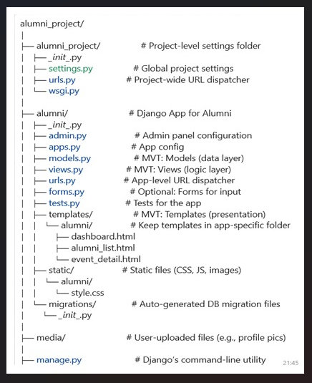

Admin_dashboard.html

Code:
{% extends 'alumni/base.html' %}
{% block content %}
<div class="container">
<h2 class="mb-4">🛠 Admin Dashboard</h2>

<div class="row mb-3">
<div class="col-md-6">
<div class="card p-3">
<h4>Total Alumni: <span class="badge bg-primary">{{ total_alumni }}</span></h4>
<h4>Total Events: <span class="badge bg-success">{{ total_events }}</span></h4>

<a href="{% url 'create_announcement' %}" class="btn btn-warning mt-3">📢 Post New Announcement</a>
<a href="{% url 'add_event' %}" class="btn btn-info mt-2">➕ Add New Event</a>
</div>
</div>
</div>

<div class="card mt-4 p-3">
<h5>Recent Event Registrations</h5>
<ul class="list-group">
{% if recent_regs %}
{% for reg in recent_regs %}
<li class="list-group-item">
{{ reg.alumni.user.get_full_name }} registered for "{{ reg.event.title }}"
</li>
{% endfor %}
{% else %}
<li class="list-group-item text-muted">No recent registrations yet.</li>
{% endif %}
</ul>
</div>
</div>
{% endblock %}

Role of admin_dashboard.html in Django:
The admin_dashboard.html template is used to display the Admin Dashboard for users with admin privileges within the Alumni Management System. This page provides essential management options for the administrator, such as:
- Viewing all alumni profiles: Admins can view and manage the information of alumni members, including contact details, graduation year, and professional updates.
- Managing alumni categories: Admins can categorize alumni based on their profession, year of graduation, or involvement in events. This helps in better organizing and filtering alumni records.
- Managing events: Admins can create, edit, and delete alumni-related events (reunions, webinars, networking events) and track attendee registrations and participation.
- Managing user roles: Admins can add/edit/remove user roles such as alumni, fellow administrators, and event coordinators, as well as manage permissions associated with each role.

Output:
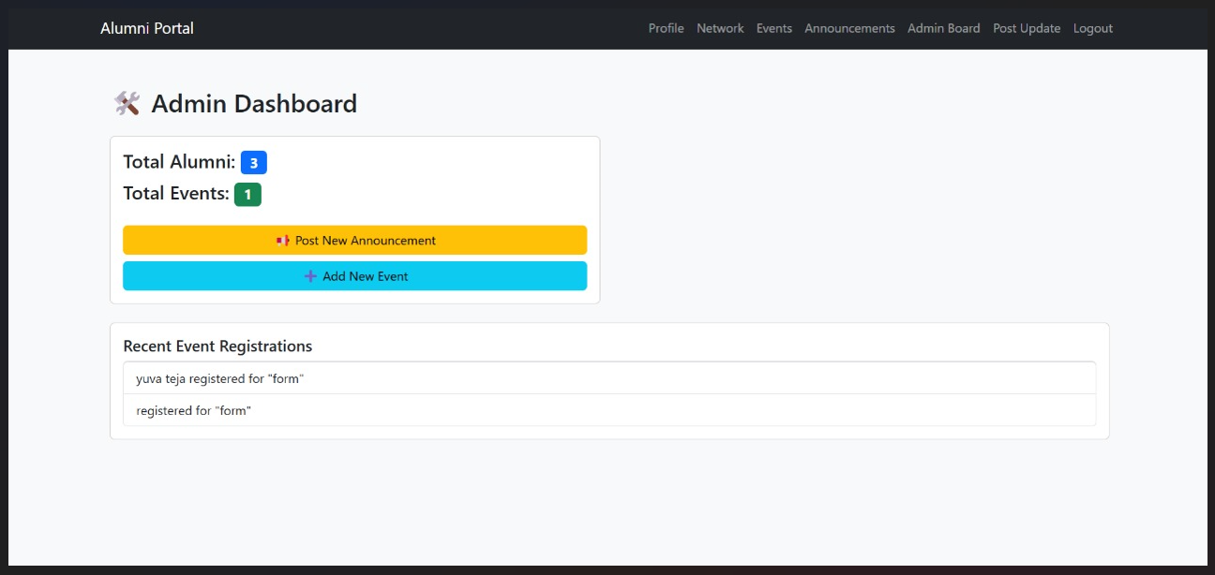

Add_event.html
Code:
{% extends 'alumni/base.html' %}
{% block content %}
<div class="container">
<h2 class="mb-4">➕ Add New Event</h2>

<form method="POST" class="card p-4">
{% csrf_token %}
{{ form.as_p }}
<button type="submit" class="btn btn-success">✅ Create Event</button>
<a href="{% url 'admin_dashboard' %}" class="btn btn-secondary ms-2">🔙 Back to Dashboard</a>
</form>
</div>
{% endblock %}

Role of add_event.html in the Alumni Management System:
The add_event.html template is used to allow administrators or event coordinators to add new events to the Alumni Management System. It provides a form where users can input details about upcoming alumni-related events.
- Displays a form to input event details: Users can enter event information such as the event name, description, date, time, location, and registration details.
- Allows selection of event type and category: Admins can categorize the event (e.g., reunion, networking event, webinar) and select the target alumni group or year.
- Prevents conflicting event dates: The system checks for any overlapping events on the same date and notifies the admin if there is a conflict.
- Sends email invitations and confirmations: Upon successful event creation, the system sends out email invitations or confirmations to registered alumni, with event details and registration links.
- Displays success or error messages: After submitting the form, the template shows a success message if the event was successfully added, or an error message if something went wrong.

Output:

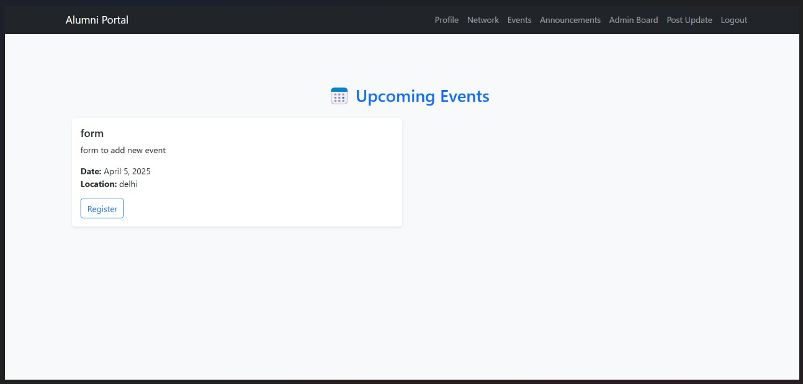

Base.html
Code:
<!DOCTYPE html>
<html lang="en">
<head>
<meta charset="UTF-8">
<title>Alumni Management System</title>
<meta name="viewport" content="width=device-width, initial-scale=1">

<!-- Bootstrap 5 CDN -->
<link href="https://cdn.jsdelivr.net/npm/bootstrap@5.3.0/dist/css/bootstrap.min.css" rel="stylesheet">

<style>
body {
background-color: #f8f9fa;
font-family: "Segoe UI", sans-serif;
}
.card {
background-color: #ffffff;
}
</style>
</head>
<body>

<nav class="navbar navbar-expand-lg navbar-dark bg-dark">
<div class="container">
<a class="navbar-brand" href="{% url 'home' %}">Alumni Portal</a>
<button class="navbar-toggler" type="button" data-bs-toggle="collapse" data-bs-target="#navMenu">
<span class="navbar-toggler-icon"></span>
</button>
<div class="collapse navbar-collapse" id="navMenu">
<ul class="navbar-nav ms-auto">
{% if user.is_authenticated %}
<li class="nav-item"><a class="nav-link" href="{% url 'profile' %}">Profile</a></li>
<li class="nav-item"><a class="nav-link" href="{% url 'alumni_list' %}">Network</a></li>
<li class="nav-item"><a class="nav-link" href="{% url 'event_list' %}">Events</a></li>

<!-- 🔥 Replace old Announcements link with this -->
<li class="nav-item">
<a class="nav-link d-flex align-items-center" href="{% url 'announcements' %}">
Announcements
{% if unread_announcement_count > 0 %}
<span class="badge bg-danger ms-2">{{ unread_announcement_count }}</span>
{% endif %}
</a>
</li>

{% if user.is_staff %}
<li class="nav-item"><a class="nav-link" href="{% url 'admin_dashboard' %}">Admin Board</a></li>
<li class="nav-item"><a class="nav-link" href="{% url 'create_announcement' %}">Post Update</a></li>
{% endif %}

<li class="nav-item"><a class="nav-link" href="{% url 'logout' %}">Logout</a></li>
{% else %}
<li class="nav-item"><a class="nav-link" href="{% url 'signup' %}">Sign Up</a></li>
<li class="nav-item"><a class="nav-link" href="{% url 'login' %}">Login</a></li>
{% endif %}
</ul>
</div>
</div>
</nav>

<main class="container py-5">
{% block content %}
{% endblock %}
</main>

<!-- Bootstrap JS -->
<script src="https://cdn.jsdelivr.net/npm/bootstrap@5.3.0/dist/js/bootstrap.bundle.min.js"></script>

</body>
</html>

Role of base.html in Django:
In Django, base.html is a common template used as the foundation for other templates in your application. It contains the common HTML structure (like <head>, <header>, <footer>, and any reusable sections) that you want to appear across multiple pages of your site.
By using base.html, you can define a consistent structure for your web pages and avoid repeating the same HTML code in every template. Other templates can extend base.html to inherit its structure, while still allowing you to inject unique content for each page.
The Base template(base.html) is the main page for our project. It allows:
- Connections from all pages
- Maintain relationships between the other templates
- Manage Navigations

create_announcement.html
Code:
{% extends 'alumni/base.html' %}
{% block content %}
<div class="container">
<h2>Create Announcement</h2>
<form method="post">
{% csrf_token %}
{{ form.as_p }}
<button class="btn btn-primary" type="submit">Post</button>
</form>
</div>
{% endblock %}

Role of create_announcement.html in Django:
The create_announcement.html template is used for creating new announcements or updates to share with alumni members. It allows admins or event coordinators to add important information or news about alumni events, programs, or initiatives.
- Displays a form to input announcement details: The form pre-fills any relevant data and allows the admin to input the title, content, and relevant date for the announcement.
- Allows admins to update and post announcements: Admins can easily create new announcements or edit existing ones before posting them to the alumni community.
- Validates form inputs before saving: The form ensures all required fields are filled correctly and validates the content before submitting the announcement.

Output:
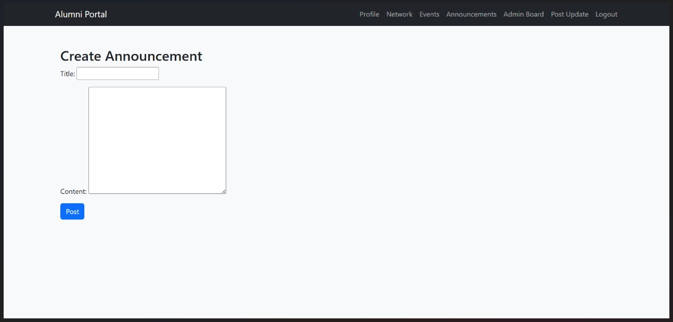

Announcement.html
Code:
{% extends 'alumni/base.html' %}
{% block content %}
<h2>Announcements</h2>
{% for ann in announcements %}
<div class="card mb-3">
<div class="card-body">
<h5 class="card-title">{{ ann.title }}</h5>
<p class="card-text">{{ ann.message }}</p>
<small class="text-muted">{{ ann.date_posted }}</small>
</div>
</div>
{% empty %}
<p>No announcements.</p>
{% endfor %}
{% endblock %}

Role of announcement.html in the Alumni Management System:
The announcement.html template is used to display and manage announcements or updates within the Alumni Management System. It allows alumni to view important news about events, initiatives, and other updates relevant to their community.
- Displays a list of recent announcements: The template shows a collection of all active announcements, including titles, dates, and summaries, so alumni can stay informed about upcoming events or important news.
Enables easy access for alumni: The template ensures a user-friendly layout and navigation, allowing alumni to stay up-to-date with minimal effort.

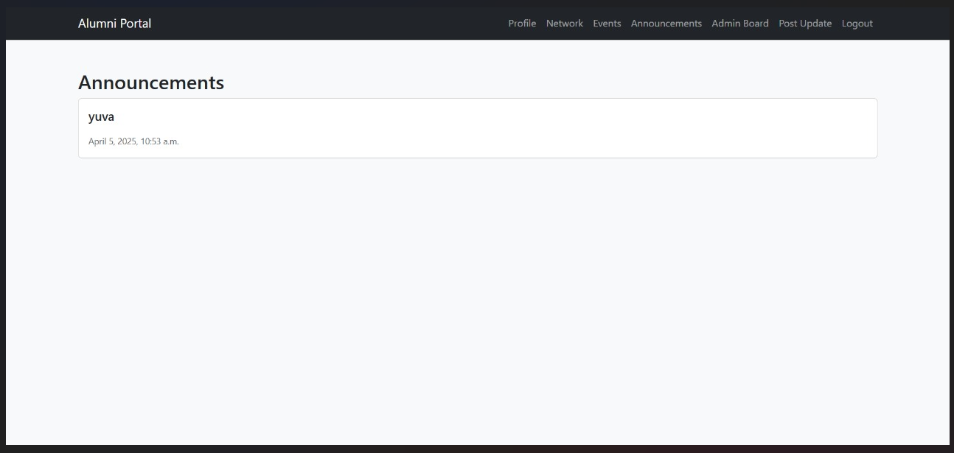
Output:
Home.html
Code:
{% extends 'alumni/base.html' %}

{% block content %}
<div class="container text-center mt-5">
<div class="card shadow p-4 border-0" style="max-width: 600px; margin: auto;">
<h2 class="mb-3 text-primary">🎓 Welcome to the Alumni Management System</h2>
<p class="lead">Stay connected, attend events, and be part of our growing alumni network.</p>
<div class="mt-4">
<a href="{% url 'signup' %}" class="btn btn-success btn-lg mx-2">Sign Up</a>
<a href="{% url 'login' %}" class="btn btn-outline-primary btn-lg mx-2">Log In</a>
</div>
</div>
</div>
{% endblock %}

Role of home.html in Django :
- Welcomes users to the alumni community: The homepage greets alumni and potential members, setting the tone for the platform.
- Displays navigation options: It provides easy access to essential links like Login, Signup, Announcements, Events, and Member Dashboard.
- Redirects logged-in alumni to their dashboard: Alumni are automatically redirected to their personalized dashboard upon login.
- Ensures unauthenticated users see login/signup options: Unauthenticated users are prompted with options to log in or sign up for access to alumni resources.

Output:
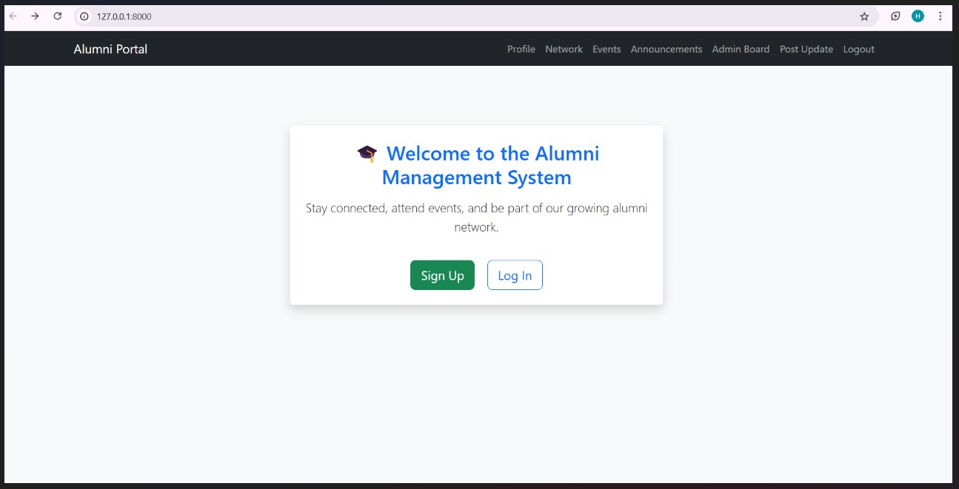

login.html
Code:
{% extends 'alumni/base.html' %}

{% block content %}
<div class="container mt-5" style="max-width: 500px;">
<div class="card shadow-sm p-4">
<h2 class="text-center mb-4">🔐 Login</h2>

<form method="POST" novalidate>
{% csrf_token %}

<div class="mb-3">
<label for="username" class="form-label">Username</label>
<input type="text" class="form-control" name="username" id="username" placeholder="Enter your username" required>
</div>

<div class="mb-3">
<label for="password" class="form-label">Password</label>
<input type="password" class="form-control" name="password" id="password" placeholder="Enter your password" required>
</div>

<div class="d-grid gap-2">
<button type="submit" class="btn btn-primary">Login</button>
</div>
</form>

<div class="mt-3 text-center">
<span>Don't have an account?</span>
<a href="{% url 'signup' %}" class="text-decoration-none">Create one</a>
</div>
</div>
</div>
{% endblock %}

Output:

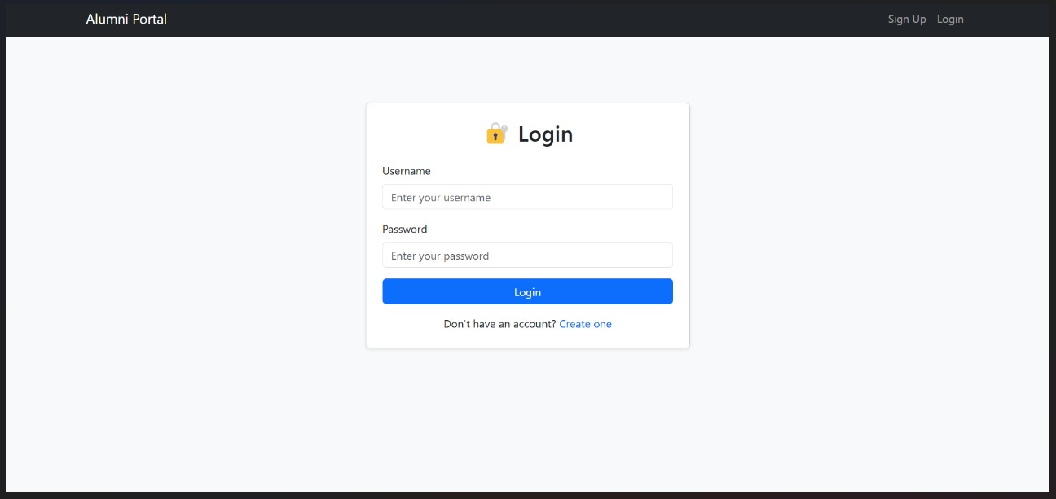

Role of login.html in Django:
The login.html template provides the user login interface for the Classroom Booking System. It allows users to enter their credentials and log in to their respective dashboards based on their role (Admin, Teacher, or Student).
- Displays a login form (username & password).
- Authenticates users using Django's built-in authentication system.
- Redirects users to their respective dashboards based on their role.
- Displays error messages if login fails.
- Provides a link to the signup page for new users.

Alumni_list.html
Code:
{% extends 'alumni/base.html' %}
{% block content %}
<div class="container mt-4">
<h2 class="text-center">🎓 Connect with Alumni</h2>
<form method="get" class="mb-3">
<input type="text" name="q" class="form-control" placeholder="Search by name or course...">
</form>

{% for a in alumni_list %}
<div class="card mb-3">
<div class="card-body">
<h5>{{ a.user.get_full_name }}</h5>
<p>{{ a.course }} ({{ a.graduation_year }}) - {{ a.job_title }}</p>
<p>{{ a.location }}</p>
{% if a.profile_picture %}
<img src="{{ a.profile_picture.url }}" width="100" class="rounded">
{% endif %}
<p>{{ a.bio }}</p>
</div>
</div>
{% endfor %}
</div>
{% endblock %}

Role of alumni_list.html in the Alumni Management System:
The alumni_list.html template is responsible for displaying all alumni profiles within the Networks section of the website.
- Fetches all alumni profiles from the database: The page retrieves and displays details such as name, graduation year, profession, and current location for each alumni.
- Displays profiles in a user-friendly format: The alumni profiles are presented in an organized list or grid layout for easy viewing by all users.
- Allows all users to view alumni information: This page is accessible to everyone, including current alumni, prospective members, and other visitors.
- Ensures public access while protecting private data: Sensitive information is omitted or restricted, allowing for public viewing of only general alumni details.

Output:
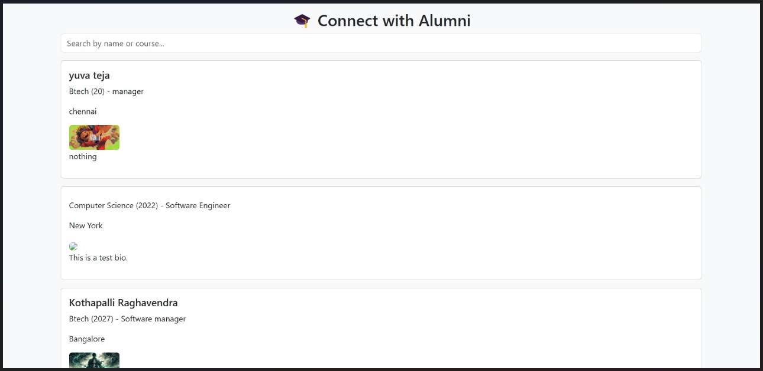

signup.html
Code:
{% extends 'alumni/base.html' %}
{% load widget_tweaks %}

{% block content %}
<div class="container mt-5" style="max-width: 750px;">
<div class="card shadow-lg p-4">
<h2 class="text-center text-primary mb-4">📝 Sign Up</h2>
<form method="post" enctype="multipart/form-data" novalidate>
{% csrf_token %}

<!-- Account Info Section -->
<div class="bg-light p-3 rounded mb-4">
<h5 class="text-secondary">👤 Account Information</h5>
<div class="row">
{% for field in user_form %}
<div class="col-md-6 mb-3">
<label class="form-label" for="{{ field.id_for_label }}">{{ field.label }}</label>
{{ field|add_class:"form-control" }}
{% if field.help_text %}
<div class="form-text">{{ field.help_text }}</div>
{% endif %}
{% for error in field.errors %}
<div class="text-danger small">{{ error }}</div>
{% endfor %}
</div>
{% endfor %}
</div>
</div>

<!-- Alumni Info Section -->
<div class="bg-light p-3 rounded mb-4">
<h5 class="text-secondary">🎓 Alumni Information</h5>
<div class="row">
{% for field in alumni_form %}
<div class="col-md-6 mb-3">
<label class="form-label" for="{{ field.id_for_label }}">{{ field.label }}</label>
{{ field|add_class:"form-control" }}
{% if field.help_text %}
<div class="form-text">{{ field.help_text }}</div>
{% endif %}
{% for error in field.errors %}
<div class="text-danger small">{{ error }}</div>
{% endfor %}
</div>
{% endfor %}
</div>
</div>

<!-- Submit Button -->
<div class="d-grid gap-2">
<button type="submit" class="btn btn-success btn-lg">Sign Up</button>
</div>
</form>

<div class="mt-4 text-center">
Already have an account?
<a href="{% url 'login' %}" class="text-decoration-none">Log in here</a>
</div>
</div>
</div>
{% endblock %}

Role of signup.html in the Alumni Management system:
- Allows new alumni to register: New users can create an account by providing basic details like name, email, and password.
- Assigns roles (Alumni, Admin): The user is assigned a role (Alumni or Admin) based on their registration details.
- Logs in the user and redirects based on their role: After signing up, users are logged in automatically and redirected to their respective dashboard or profile page. Authenticated users cannot access the signup page again.

Output:
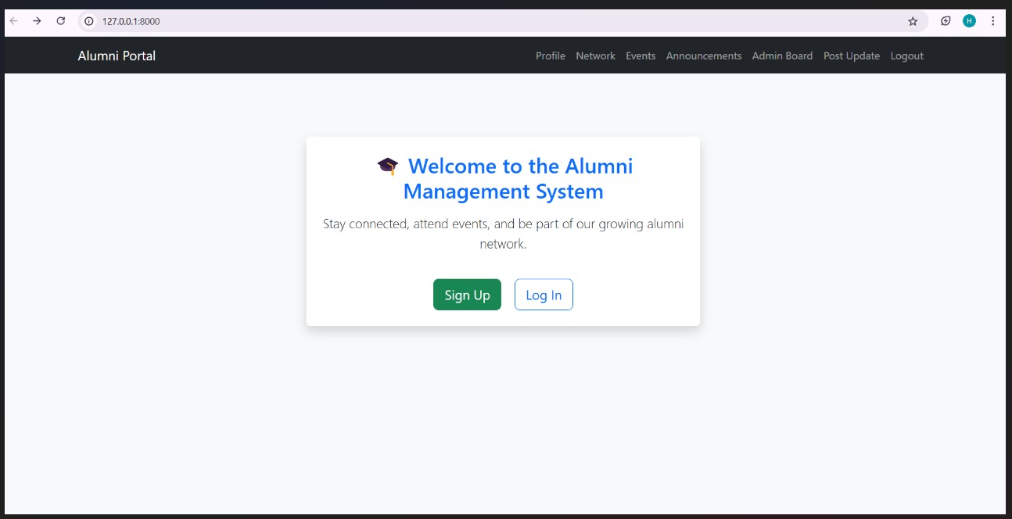

profile.html
Code:
{% extends 'alumni/base.html' %}

{% block content %}
<div class="container mt-5" style="max-width: 700px;">
<div class="card p-4 shadow-sm">
<h2 class="mb-4 text-center text-primary">👤 Your Profile</h2>

<form method="POST" enctype="multipart/form-data" novalidate>
{% csrf_token %}

{% for field in form %}
<div class="mb-3">
<label class="form-label" for="{{ field.id_for_label }}">{{ field.label }}</label>
{{ field }}
{% if field.help_text %}
<div class="form-text">{{ field.help_text }}</div>
{% endif %}
{% for error in field.errors %}
<div class="text-danger">{{ error }}</div>
{% endfor %}
</div>
{% endfor %}

<div class="d-grid gap-2">
<button type="submit" class="btn btn-success">Update Profile</button>
</div>
</form>

<div class="text-center mt-3">
<a href="{% url 'event_list' %}" class="btn btn-outline-primary">📅 View Events</a>
</div>
</div>
</div>
{% endblock %}

Role of Profile.html in Alumni Management System:
The profile.html template serves as the homepage for alumni members after they log in. It allows alumni to:
- View and update personal details: Alumni can see and modify their profile information, such as name, contact details, education, and career information.
- Ensure secure access: Only the logged-in user can access and edit their own profile, preventing unauthorized modifications.
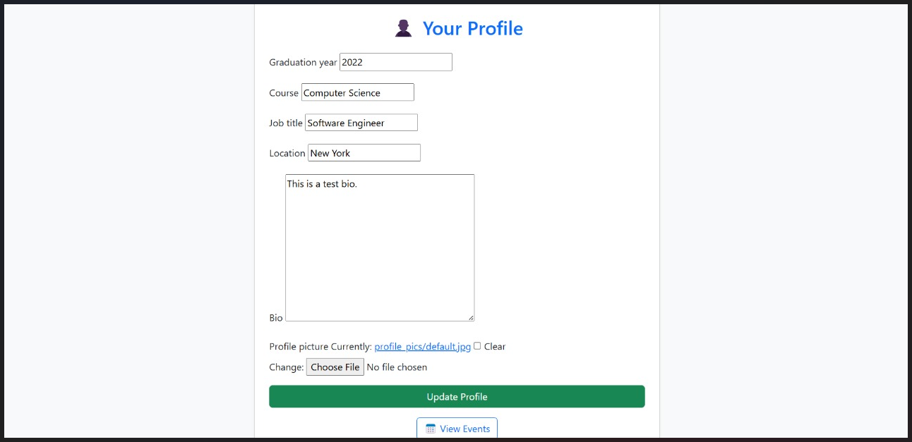
Output:

Forms.py in Django
What is forms.py in Django:
In Django, forms.py is used to handle user input efficiently and securely. It allows developers to create and manage forms without manually writing HTML and validation logic. This file is essential in creating, validating, and processing forms for user interaction on a Django web application.
Why Use forms.py:
- Simplifies Form Creation: Django provides built-in form classes to create forms quickly without the need to manually write HTML.
- Handles Input Validation Automatically: Django automatically handles form validation (e.g., checking if fields are filled in correctly, the right data types, etc.).
- Integrates with Django Models: Forms can be tied directly to Django models, which means data can be directly stored in the database without manually writing additional code.
- Prevents Security Risks: Django forms help prevent common web security issues like SQL Injection and Cross-Site Request Forgery (CSRF) attacks by
- automatically handling and sanitizing input data.
Code:
# myapp1/forms.py
from django import forms
from django.contrib.auth.models import User
from .models import Alumni

class UserRegisterForm(forms.ModelForm):
password = forms.CharField(widget=forms.PasswordInput)

class Meta:
model = User
fields = ['username', 'email', 'password', 'first_name', 'last_name']

class AlumniForm(forms.ModelForm):
class Meta:
model = Alumni
fields = ['graduation_year', 'course', 'job_title', 'location', 'bio', 'profile_picture']
from .models import Announcement

class AnnouncementForm(forms.ModelForm):
class Meta:
model = Announcement
fields = ['title', 'content']
from django import forms
from .models import Event

class EventForm(forms.ModelForm):
class Meta:
model = Event
fields = ['title', 'description', 'date', 'location']
widgets = {
'date': forms.DateInput(attrs={'type': 'date'}),

MODELS.PY:
What is models.py in Django:
In Django, models.py is where you define the database structure using Python code. Django models act as a bridge between the database and the application, allowing you to create, read, update, and delete records easily.
Why Use Django Models:
- No need to write raw SQL queries.
- Automatically creates tables in the database.
How to Apply Models:
Create the Model in models.py:
- Write your models inside the models.py file.

Code:
# myapp1/models.py
from django.contrib.auth.models import User
from django.db import models

class Alumni(models.Model):
user = models.OneToOneField(User, on_delete=models.CASCADE)
graduation_year = models.IntegerField()
course = models.CharField(max_length=100)
job_title = models.CharField(max_length=100, blank=True)
location = models.CharField(max_length=100, blank=True)
bio = models.TextField(blank=True)
profile_picture = models.ImageField(upload_to='profiles/', blank=True)

def _str_(self):
return self.user.get_full_name()

class Event(models.Model):
title = models.CharField(max_length=200)
description = models.TextField()
date = models.DateField()
location = models.CharField(max_length=200)
image = models.ImageField(upload_to='events/', blank=True)

def _str_(self):
return self.title

class EventRegistration(models.Model):
event = models.ForeignKey(Event, on_delete=models.CASCADE)
alumni = models.ForeignKey(Alumni, on_delete=models.CASCADE)
registered_at = models.DateTimeField(auto_now_add=True)

def _str_(self):
return f"{self.alumni.user.username} -> {self.event.title}"
class Announcement(models.Model):
title = models.CharField(max_length=200)
content = models.TextField()
date_posted = models.DateTimeField(auto_now_add=True)

def _str_(self):
return self.title
# models.py
class AnnouncementReadStatus(models.Model):
alumni = models.ForeignKey(Alumni, on_delete=models.CASCADE)
announcement = models.ForeignKey(Announcement, on_delete=models.CASCADE)
read = models.BooleanField(default=False)

Database in Django:
Django uses SQLite by default. The database is stored as a single file named db.sqlite3 in your project directory.
Code:

DATABASES = {
'default': {
'ENGINE': 'django.db.backends.sqlite3', # The database engine
'NAME': BASE_DIR / 'db.sqlite3', # The SQLite database file
}
}
How Databases Store in Django:
- Django models define how data is structured.
- Migrations (python manage.py migrate) create tables in the database.

Run Migrations to Create Database Tables:
After defining your models, run the following commands to apply them to the database:
- python manage.py makemigrations
- python manage.py migrate

Running Migrations to Create Database Tables in Django
1. Introduction to Migrations in Django Migrations are a way of applying changes you make to your Django models to your database schema. Django uses migrations to manage database schema changes and ensure that your database structure is always up to date with the models you define.
Django has a built-in migration system that helps with:
- Creating new tables
- Adding or removing fields in models
- Renaming models or fields
- Changing data types
Migrations provide a structured, automated way to propagate changes in your application’s schema without losing data.

2. Defining Models in Django:Models in Django are Python classes that define the structure of your database tables. They provide a simple way to describe the structure of your data and how it should be stored in the database.
Here’s an example of defining a model:

from django.db import models
class Alumni(models.Model):
name = models.CharField(max_length=100)
Passout year = models.IntegerField()
email = models.EmailField()

def __str__(self):
return self.name

This model creates a table with the columns name, passout year, and email. Once this model is defined, Django will automatically generate the necessary SQL to create the corresponding table in the database.

3. Running Migrations to Create Database Tables After defining your models in models.py, you need to create migrations to apply these changes to your database.

Make Migrations
The first step is to create the migration file that contains the instructions to apply your model changes to the database. To do this, run the following command:

>>python manage.py makemigrations

This will create a migration file in your migrations/ directory under the app folder. The migration file will contain instructions like "Create model Alumni_portal" or "Add field email to model Aumni_portal."

Step 2: Apply Migrations
After creating the migrations, you need to apply them to your database to create the tables. Run the following command:
>>python manage.py migrate
This command will:
- Apply any pending migrations.
- Create the database tables.
- Ensure that your database schema is up-to-date with the models you defined.
If everything is correct, Django will display output like:
Operations to perform:
Apply all migrations: alumni_portal
Running migrations:
Applying app_name.0001_initial... OK

4. Common Migration Operations
In addition to creating tables, migrations can also handle the following changes:
4.1 Adding Fields
To add a new field to an existing model, you just modify the model and then run make migrations again.
Example: Adding a new field of date_of_birth to the Alumni model.

class Alumni(models.Model):
name = models.CharField(max_length=100)
passedoutyear = models.IntegerField()
email = models.EmailField()
date_of_birth = models.DateField(null=True)

Run the following commands:

>>python manage.py makemigrations
>>python manage.py migrate

4.2 Renaming Models or Fields
Django provides migration commands to handle renaming models or fields. For example, renaming a model from Student to Learner can be done with:

>>python manage.py makemigrations
>>python manage.py migrate

Django will generate the necessary instructions to rename the table and any related field references in the database.

5. Handling Migration Errors
Sometimes, you may encounter issues while running migrations. Here are some common errors and solutions:

5.1 Missing Migration Files
If you accidentally delete a migration file or if migrations are out of sync, you can regenerate migrations by deleting the migration folder (except for __init__.py) and then running:
>>python manage.py makemigrations

5.2 Database Errors
If migrations fail due to database errors, you might need to inspect the error message and resolve the issue. For example, if the migration can’t create a table because it already exists, you may need to drop the existing table or use the --fake option to mark the migration as applied without changing the database schema.

6. Resetting Migrations Sometimes, during development, you may need to reset migrations if the migrations become too complex or messy. Here’s how you can do that:
- Delete Migration Files: Delete all migration files in your app's migrations folder (except for __init__.py).
- Run make migrations and migrate again to regenerate and apply new migrations.

Conclusion
Django migrations are a powerful feature that allows you to manage changes to your database schema in a clean and structured way. By using make migrations and migrate, you ensure that your database tables always reflect the structure of your models, making your development process smoother and safer.

DATABASE INTEGRATION
Database integration in Django is an essential part of building a web application, allowing you to store, retrieve, and manipulate data efficiently. Django integrates with databases through its Object-Relational Mapping (ORM) system, which allows you to define your database schema using Python classes (models) instead of writing raw SQL queries. Below, I’ll walk you through the basics of integrating a database in Django:
1. Database Configuration in Django
By default, Django uses SQLite as its database backend, but you can easily configure it to use other databases like PostgreSQL, MySQL, or Oracle.
To configure your database, you need to edit the DATABASES setting in your settings.py file.
Example for SQLite (default):
DATABASES = {
'default': {
'ENGINE': 'django.db.backends.sqlite3',
'NAME': BASE_DIR / 'db.sqlite3',
}
}

2. Defining Models
In Django, models represent the structure of your database tables. You define a model as a Python class that inherits from django.db.models.Model. Each model class corresponds to a table in your database, and each class attribute corresponds to a column in the table.
Example:
from django.db import models
class Alumni(models.Model):
name = models.CharField(max_length=100)
Passout year = models.IntegerField()
email = models.EmailField()

def __str__(self):
return self.name

This model will create a Student table in the database with columns for name, roll_number, and email.

3. Running Migrations
After defining or modifying models, you need to run migrations to create or update the corresponding tables in the database. Migrations are Django’s way of tracking changes to your models and applying them to the database.
To create migration files for your models, run the following command:
>>python manage.py makemigrations
This will create a migration file in the migrations/ directory of your app.

To apply the migrations and create/update the database tables, run:
>>python manage.py migrate
For your Alumni Management System project, you will need to integrate a database to handle various pieces of data such as user profiles, new events, announcements and networks. Below is an overview of how to set up database integration for your project, including the necessary models and steps to handle different aspects of your application.
1. Setting Up the Database:
Since you're using SQLite for your project (as mentioned earlier), Django will automatically create a database for you when you run the migrations. If you wish to use a different database such as PostgreSQL or MySQL in production, you can configure it as described in the previous message.
2. Defining Models for the Alumni Management System:
You'll need several models to store the data for user profiles, new events, announcements and networks. Below is an example of how to define these models in Django:
User Model
Django comes with a built-in user model (django.contrib.auth.models.User), which includes basic fields like username, password, email, etc. However, you might want to extend it if you need extra fields specific to your application, like user preferences.

class Alumni(models.Model):
user = models.OneToOneField(User, on_delete=models.CASCADE)
graduation_year = models.IntegerField()
course = models.CharField(max_length=100)
job_title = models.CharField(max_length=100, blank=True)
location = models.CharField(max_length=100, blank=True)
bio = models.TextField(blank=True)
profile_picture = models.ImageField(upload_to='profiles/', blank=True)

def _str_(self):
return self.user.get_full_name()

Event model
This event model give the information about the upcoming events update

class Event(models.Model):
title = models.CharField(max_length=200)
description = models.TextField()
date = models.DateField()
location = models.CharField(max_length=200)
image = models.ImageField(upload_to='events/', blank=True)

def _str_(self):
return self.title

Event registration Model
This event registration model is used for the registration for the event this is upcoming on conduct ahead.
class EventRegistration(models.Model):
event = models.ForeignKey(Event, on_delete=models.CASCADE)
alumni = models.ForeignKey(Alumni, on_delete=models.CASCADE)
registered_at = models.DateTimeField(auto_now_add=True)

def _str_(self):
return f"{self.alumni.user.username} -> {self.event.title}"

Announcement Model
The main purpose of the announcement model is to notify about the upcoming updates and gives you information about the current situations.
class Announcement(models.Model):
title = models.CharField(max_length=200)
content = models.TextField()
date_posted = models.DateTimeField(auto_now_add=True)

def _str_(self):
return self.title

AnnouncementReadStatus Model
This AnouncementReadStatus model is uessd to check and give the information about the announcement related queries.
class AnnouncementReadStatus(models.Model):
alumni = models.ForeignKey(Alumni, on_delete=models.CASCADE)
announcement = models.ForeignKey(Announcement, on_delete=models.CASCADE)
read = models.BooleanField(default=False)

3. Run Migrations
Once you've defined your models, you'll need to run migrations to create the corresponding database tables.
>>python manage.py makemigrations
>>python manage.py migrate
These commands will generate and apply the migration files, creating the tables in your database.
4. Admin Integration
To manage these models through Django's built-in admin panel, register them in the admin.py file.
from django.contrib import admin
from .models import Alumni, Event, EventRegistration,Announcement

admin.site.register(Alumni)
admin.site.register(Event)
admin.site.register(EventRegistration)
admin.site.register(Announcement)

After this, you can log in to the admin interface (http://127.0.0.1:8000/admin/) and manage the data.
5. Creating Views to Interact with the Database
Now that your models are set up and your database is created, you can build views to allow users to interact with the data. Below are some basic views to display the study groups, upload videos, and manage notes.

Views for Displaying Profile
from django.shortcuts import render
from .models import profile

def profile(request):
alumni = get_object_or_404(Alumni, user=request.user)
if request.method == 'POST':
form = AlumniForm(request.POST, request.FILES, instance=alumni)
if form.is_valid():
form.save()
else:
form = AlumniForm(instance=alumni)
return render(request, 'alumni/profile.html', {'form': form})

View for Uploading Announcements
from django.shortcuts import render, redirect
from .forms import Announcement

def announcements(request):
from .models import Announcement
announcements = Announcement.objects.order_by('-date_posted')
return render(request, 'alumni/announcements.html', {'announcements': announcements})

View for add_event
from django.shortcuts import render, redirect
from .forms import add_event

def add_event(request):
if request.method == 'POST':
form = EventForm(request.POST)
if form.is_valid():
form.save()
messages.success(request, 'Event created successfully!')
return redirect('admin_dashboard')
else:
form = EventForm()
return render(request, 'alumni/add_event.html', {'form': form})

6. Forms for Handling Data Input
For handling form submissions like study material uploads and notes, you need to create forms.
Example for Study Material Form (forms.py):
from django import forms
from .models import StudyMaterial

class StudyMaterialForm(forms.ModelForm):
class Meta:
model = StudyMaterial
fields = ['title', 'subject', 'description', 'file']

Conclusion
By setting up the models, migrations, views, and forms, you can integrate a fully functional database into your Alumni Management System application. Users will be able to join events, upload the education status and interact with seniors, chat with them and interact with each other in a seamless, database-driven environment.

5. Database Administration
Django provides an admin interface that allows you to manage the database through a web interface. To enable the admin interface:
- Add 'django.contrib.admin' to the INSTALLED_APPS in settings.py.
- Create a superuser by running:
>>python manage.py createsuperuser
- Run the server:
>>python manage.py runserver
- Visit http://127.0.0.1:8000/admin and log in with the superuser credentials to manage your database.
6. Handling Database Migrations in Production
When you deploy your Django application to a production environment, you need to ensure your migrations are applied correctly. This typically involves running makemigrations and migrate as part of your deployment process.
For example, when deploying to a cloud service or production server, you might run these commands:
>>python manage.py makemigrations
>>python manage.py migrate
7. Database Transactions
Django provides support for database transactions, allowing you to ensure that a set of operations are executed atomically. This can be useful when you need to ensure data consistency and avoid partial updates.

8. Database Indexing and Optimization
To improve the performance of database queries, Django allows you to add indexes to your models. You can define indexes in your model to optimize query performance.

Deploying Django Web Application on Cloud
What is Deployment?
Deployment is the process of making a Django web application live on the internet so users can access it. This involves hosting your app on a cloud server like AWS, Google Cloud, DigitalOcean, Heroku, or PythonAnywhere.
Features:
- Scalability – Handle more users without performance issues.
- Security – Protect user data with SSL and secure databases.
- Global Accessibility – Users can access your app from anywhere.
- Continuous Deployment – Easily update your app with new features.
  - Here's a step-by-step guide to Register on GitHub, Create a Django website with login and registration pages, and Configure Django to handle static files.
Step 1: Register on GitHub
- Go to GitHub and click Sign up.
- Enter your Username, Email, and Password.
- Complete the verification and click Create Account.
- Verify your email by clicking the link in your inbox.
Step 2: Push to GitHub
- Initialize Git in your project:
git init
https://github.com/hemanthkumar120/Hemanthkumar.git
- Connect to GitHub:
git remote add origin
- Add and commit changes:
git add .
git commit -m "Initial Commit: Login and Registration App"
- Push to GitHub:
git branch -M main
git push -u origin main
You have successfully built a Django website with login, registration, and static file management. Your code is now available on GitHub.
GITHUB LINK:
https://github.com/hemanthkumar120/Hemanthkumar.git

FRONT END WEB DEVELOPMENT CERTIFICATION



